.”
Servants to All AllNameServant
Email: servantstoall@comcast.net  Website: www.servantstoall.org | Tel: 570-729-2917  Fax: 570-728-2918  4 South Centre Street, Pottsville, PA 17901

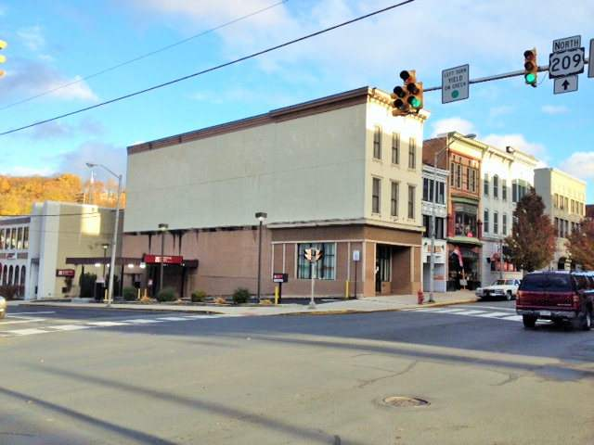
“Working Together to End Homelessness in Schuylkill County.”

ANNUAL REPORT

2022
TABLE OF CONTENTS
TABLE OF CONTENT ____________________________________________ 2

MISSION ______________________________________________________ 3

VISION ________________________________________________________3

ABOUT US _________________________________ 4

SERVICES PROVIDED __________________________________________ 5

TARGET POPULATION _________________________________________ 5

PROGRAMS _________________________________________________6-7

IMPACT ______________________________________________________ 8

FINANCIAL OVERVIEW _________________________________________ 9

NEW PROJECTS 10

BOARD OF DIRECTORS ________________ 11

STAFF _______________________________________________________ 12

STAKEHOLDERS_______________________________________________13

CONTACT INFORMATION

About Servants to All

Mission
Through the Love of the Father, we work to restore dignity, build integrity, instill accountability, and thus transform the lives of poor and displaced individuals and families. Our programs are tailored to foster self-reliance and sustainability by empowering individuals to make positive life choices. Because we are God’s first, we are servants to all.

Vision
We believe in “community”; a cohesive society which encourages, supports, and provides opportunity for each member to realize the highest and best use of their God given talents. Being uniquely created by God with talent and dignity; every individual, especially the poor, homeless, and elderly, is meant by God to support and be supported by their community in order to create growth and flourish. No person is a solitary being.

Celebrating 10 Years of Service
It is hard to believe that ten years ago, a wonderful group of people got together with the mission to help the homeless. Servants to All has been serving the homeless 2012. At the time there were no homeless shelters in Schuylkill County for men and women, but a greater need existed and was going unmet. People in the area found themselves homeless for a wide variety of reasons, including alcohol or drug issues, loss of employment, or illness. For these individuals, limited homeless service providers meant that transitioning back into life after homelessness was a challenge which may have seemed insurmountable. People who found themselves in desperate situations now have one centralized location where they can receive housing, meals, case management, and referrals that are best suited to fit all of their needs.

About Us
On September 26, 2012 Servants to All incorporated and was granted tax exempt status under Section 501 (c)(3) of the IRS Code. From February 2014 to May 7, 2014 Servants to All operated a temporary winter shelter and rotated its program between churches. On December 1, 2014 Servants to All purchased the day program building located on Centre Street in Pottsville. From December 8, 2014 through March 15, 2015 Servants to All opened to distribute clothing and supplies to the poor and homeless during the cold winter months. On June 19, 2015, Servants to All was granted an occupancy permit from the City. November 11, 2015, Servants to All opened My Father’s House. On November 15, 2016, Servants to All opened its overnight men's shelter in permanent location in Pottsville and has been striving since. In February 2018, Servants to All expended services to both men and women at the overnight shelter.

In December 2019, Servants to All began our Street Outreach program, and in January 2020 we incorporated Homeless Prevention services. Servants to All also became a Connect To Home: Coordinated Entry System (CES) of Eastern PA Access Site and began to provide services in August 2019. Servants to All receives a large influx of referrals for families in need of shelter. Access Sites coordinate and manage access, assessment, prioritization and referrals to housing and services for any person(s) experiencing or at imminent risk of homelessness.

Today, Servants to All employees five full time and numerous volunteers that continue the work that our board of directors began in 2012. The board of directors began Servants to All with the mission to help those in need. The current board is comprised of individuals from Schuylkill County that bring diverse skills, experience, and perspective to the program. We have one centralized location where they can receive housing, meals, and case management to fit their needs. These individuals are offered supportive services that may include transportation, assistance with housing applications, benefits, or employment, goal planning, health and wellness, educational, and referrals to human service agencies.

Services Provided
Servants to All is a faith based program, and the only emergency shelter program in Schuylkill County that serves the general population. The agency is also the point of access from Coordinated Entry to the homeless system. The program provides emergency shelter to the homeless, homeless prevention, street outreach, supportive services, and daily case manager services.

Target Population
Servants to All assists vulnerable populations such as veterans, persons with disabilities, re-entry population from incarceration, families and youth. Servants to All also supports the needs of the elderly in collaboration with local Senior Services and Adult Protective Services. We seek out and serve individuals who are sleeping in places not meant for human habitation, people being discharged from an institution with no permanent residence available, people who would be discharged from an institution if there was a permanent residence available, displaced victims of domestic violence, and those at risk of homelessness due to financial difficulty. There are no fees for any serves provided by Servants to All.

PROGRAMS
EMERGENCY SHELTER
Servants to All operates an emergency shelter program and temporary shelter assistance. Servants to All utilizes SRO’s (single room occupancies) for individual, and families shelter rooms for families with minor children. For clients with unique needs that exceed overnight shelter and where it has been determined that no other appropriate shelter is available, Servants to All may cover the cost of providing temporary shelter in hotels and motels through vouchers. Servants to All is a short-term housing program designed to assisted homeless individuals while working to obtain permanent housing. Housing may be extended beyond thirty days if the client is activity working on their goals established with their case manager and is compliant with program guidelines.

SUPPORTIVE SERVICES
Servants to All provides basic necessities such as food, clothing, and hygiene products to any member of the community in need of assistance. Homeless clients are also provided food, clothing, laundry machines, transportation, and funding for replacement identification documents and prescription co-payments. Computer workstations, mentors, motivational speakers, and spiritual support are also offered.

CASE MANAGEMENT
Case management services is essential in helping the homeless achieve permanent and stabilized housing and sustainable independence. Case managers assist clients with goal planning, housing, and employment goals. In-person meetings occur between the case workers and the client to facilitate the goal-setting process and to discuss progress daily.

MOTEL VOUCHERS
Servants to All utilizes hotel/motel vouchers for individuals or families that are homeless and in need of temporary shelter when the shelter program is at capacity, individuals may require special accommodations, or clients present after normal business hours. If there is not a vacancy in the shelter program, a hotel/motel voucher may be provided. Hotel/motel vouchers are not intended for long term placement.

CODE BLUE
Hotel/motel vouchers are a critical during the winter months due to the lack of a physical code blue shelter. Local police and emergency personnel are authorized to issue motels vouchers after in the evening or on the weekends on behalf of Servants to All, if they encounter a homeless individual or family. Vouchers may be provided at a local motel for those who are homeless on the street, in an unheated structure, or place not appropriate for human habitation. Clients are provided accommodations at local hotels that allow clients a private space to sleep, eat and bathe.

STREET OUTREACH
Servants to All provides essential services necessary to reach out to unsheltered homeless people; connect them with emergency shelter, housing, or critical services; and provide urgent, non-facility-based care to unsheltered homeless people who are unwilling or unable to access emergency shelter, housing, or an appropriate health facility. Servants to All’s Street Outreach focuses on supporting homeless households in achieving some form of permanent, sustainable housing.

The Street Outreach Case Manager implements engagement activities including locating, identifying, and building relationships with unsheltered homeless people. The case manager provides immediate support, intervention, and connections with homeless assistance programs and/or mainstream social services and housing programs. The Case Manager will connect those identified through Street Outreach activities with emergency shelter, housing, or critical services, and provide urgent, non-facility-based care to unsheltered homeless people who are unwilling or unable to access emergency shelter, housing, or an appropriate facility.

STREET MEDICINE
Street Medicine is the practice of providing medical care to unsheltered people experiencing homelessness in locations like encampments, parks, and under bridges. Many reasons prevent people experiencing homelessness from accessing medical treatment in traditional settings. These include the theft or destruction of unattended personal property, the effects of trauma and prior negative treatment from mainstream health providers, and the need to prioritize basic human needs such as food, shelter, restrooms, etc. Street medicine providers can provide the same primary care services on the street as they can in physical clinics.

HOMELESS PREVENTION
Servants to All provides homeless prevention services that include Case Management, Financial Assistance, and Rental Assistance. A Housing Stability Case Manager works with the client to develop a housing-oriented goal plan to obtain housing stabilization, assists with planning and attaining goals, and housing applications. Eligible participants are enrolled in the program, and verification of documentation is completed of the client’s financial, housing, and family size. Income is verified in accordance with the HUD income eligibility guidelines, individuals and families must have annual incomes below thirty percent (30%) of the area median income. The process enables case managers to identify barriers preventing the client from becoming self-sufficient. During case management a client Goal Plan is developed. Rental assistance and financial assistance may be provided to individuals and families who are at imminent risk, or at risk of homelessness.

PA 211 CES ACCESS SITE
Servants to All began providing service as the point of access from Coordinated Entry to the homeless system in Schuylkill County.

IMPACT IN 2022
Rosemary’s Success Story
Success, often built upon small steps, is often not done in our chosen timing. What is most important is consistency, authenticity, and engagement. As in the case of Rosemary, that looked like a year of three-minute engagement conversations asking if she was okay and if she had eaten that day. During this time, Rosemary began the process of trusting again. There were many burnt bridges, and many barriers, but she kept showing up. She began working with street outreach with this engagement. When she felt like she was able to trust enough, the case manager tried to send out for her documents and start the process for applying for housing. Eventually, Rosemary sought lifesaving services. When she completed that program, she had a warm handed off to the shelter. She continued to work on the goals that the case manager had started in street outreach, building on the small steps she had previously taken.

Rosemary enrolled in school. She obtained her documentation and employment. Starting to break down the barriers she once had had, Rosemary graduated to a long-term program that upon completion, would lead to permanent housing. She has even referred others to us because she knew we would show up when someone needs help. Looking back no one could guess that those many spontaneous three minutes of engagement would lead to such a beautiful transformation in her life. This is why it is so important to be consistent, persistent, and authentic. This is how seamlessly the different grants work together within Servants to All, and programs within the community with our partner agencies. We are all so proud of her accomplishments. At the right time that she was ready, she took her first step on her path to the life she was meant to have.

2022 | Clients  Served
Emergency Shelter | 313
Motel Vouchers | 212
Supportive Services | 740
Homeless Prevention | 111
Rental Assistance | 75
Street Outreach | 47
211 Referrals | 704
Melissa’s Success Story
Melissa came to the family shelter had just after relocated from Florida. She had nothing but hope and dream of where she wanted to be with her two daughters, ages 13 and 4. Melissa worked every day towards her goal of giving herself and her girls. Her goals was to find a home in the middle of Christmas and she made it all happen. She found employment, school for the girls, and housing. Melissa was also fiercely passionate of working towards her dreams. She worked hard for her family, and on Christmas day she was in an apartment, a place she could call home.

FINANCIAL OVERVIEW 2022

STATEMENT OF ACTIVITIES FOR THE YEAR ENDING 12/31/21
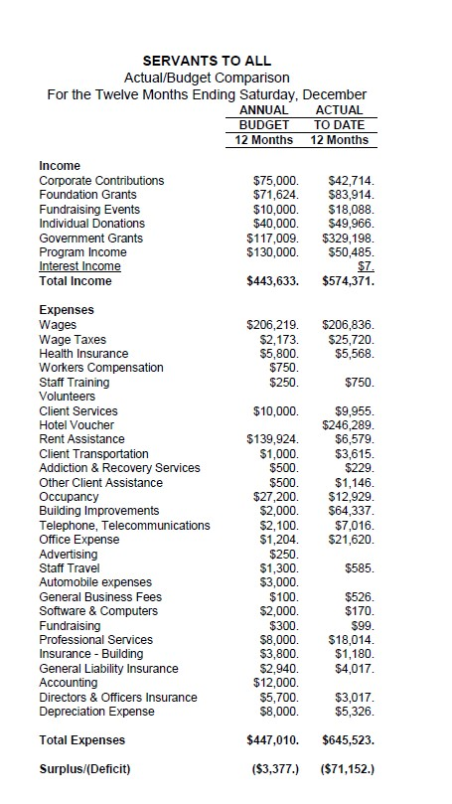

NEWs projects

STREET MEDICINE
The St Luke’s Rural Family Medicine Residency began a “street medicine” program in November of 2022. It is designed to provide walk-in primary care services to clients of Servants to All PA. The Rural Residency sees patients at STA on Tuesday afternoons. Patients are identified by outreach coordinators, medical advocates, or other representatives from their respective institutions.

Patients with urgent needs have been seen through telemedicine when the technology was available. Patients are seen on an as-needed, walk-in basis regardless of their ability to pay. Previously, these patients were utilizing urgent care or the emergency department for simple things like getting routine medications refilled. Often, patients would wait weeks to see a primary care physician in the area. Because we function as a federally designated Rural Health Clinic, we can see these patients as home visits, even if their home is temporary.

The Rural Residency has conducted multiple patient encounters, including seeing patients at a wooded encampments and at Servants to All. Our Rural Residency has collaborated with Servants to All to provide timely, cost-effective care to vulnerable populations in Schuylkill County.
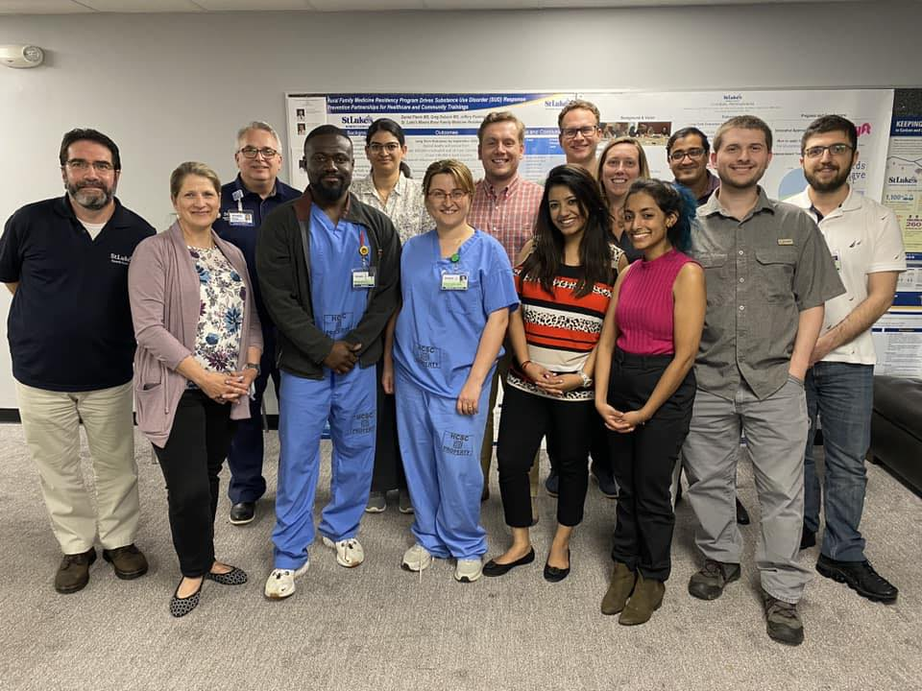 | 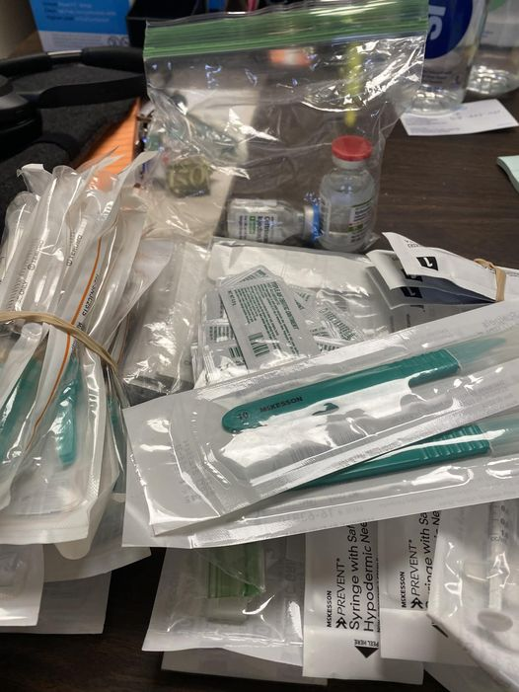 | 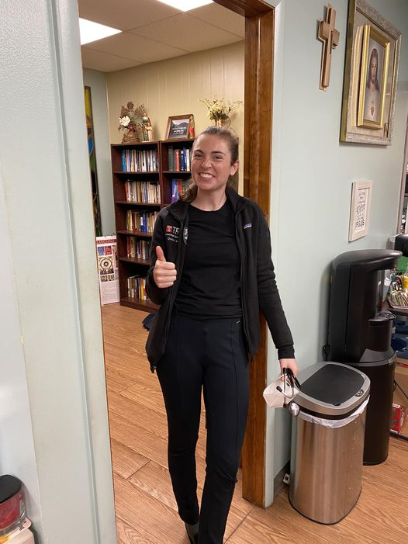

board of director

2023 EXECUTIVE BOARD
- PRESIDENT - Jeanne Boyer-Porter – New Life Thrift Stores, Owner
- VICE PRESIDENT – Wayne Herring – Rte 61 Classics and Toy Barn, LLC, Owner
- TREASURER - Michael Scheidel, M.Ed – Co-Founder of Little Peace Farm
- SECRETARY – William Gianfagna, MD – Physician, Geisinger Pediatrics
- PAST PRESIDENT - Gerald Achenbach, Ed.D. – Past Housing Director

BOARD MEMBERS
- Teresa Santai Gaffney - Schuylkill County Register of Wills
- Paul Domalakes, Esquire – Partner; Rubright, Domalakes, Troy & McDonald
- Brendt Geiger – Max Finkelstein
- Karen Kenderdine - Mid Penn Bank, Senior Vice President & Manager of Relationship Services
- Colleen Jones- Preferred Warranties, Inc., Claims Manager
- Jennifer Wallace - Social Worker
- Debra Herring – Advocate for the homeless
- Emily Scheidel – Co-Founder of Little Peace Farm
- Dale Verchick – Disability Rights Advocate
- Jeanette Triano Sinn – Servants to All, Executive Director

STAFF

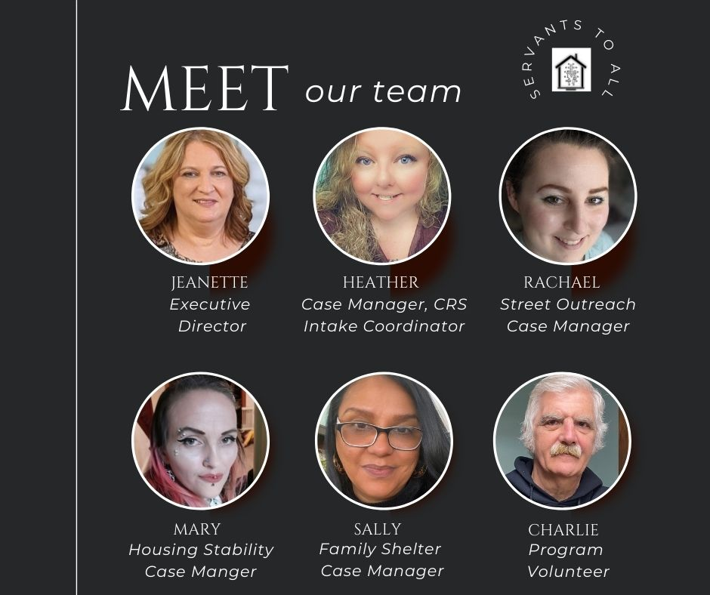

Stakeholders

All One Foundation
Amazon Smile
Big Lots – The Columbus Foundation
Capital Blue Cross
Catholic Women's Society of Giving
Catholic Human Service Foundation
Costco
County of Schuylkill
Delaplaine Foundation
Diocese of Allentown - Local Poverty Relief
Donald and Dorothy Stabler Foundation
First Federal Community Foundation
Geisinger
Guz's Charitable Project
Home4Good
Home Depot
Housing Alliance of Pennsylvania
Lowe's Heroes
M&T Bank
Moses Taylor Foundation
Pennsylvania Housing Alliance
Pottsville Rotary
Same Kind Foundation
Santander Bank
Schuylkill County Council of Churches
Schuylkill Community Action
Schuylkill Community Area Foundation
Schuylkill County Affordable Trust Fund
Schuylkill County Office of Mental Health
Service Access and Management, Inc.
Solar Innovations - Solar Cares
Stewardship Ministries
The Columbus Foundation – Big Lots
The County of Schuylkill
The Delaplaine Foundation
The United Way – Schuylkill County (Emergency Food & Shelter Program)
The Weinberg Foundation
UPMC
Walmart
Wells Fargo

For ServICES OR MORE INFORMATIOn PLEASE CONTACT:
4 South Centre Street
Pottsville, PA 17901

Phone: (570) 728-2917
Intakes: (570) 900-1161
Street Outreach: (570) 573-3449
Fax: (570) 728-2918
EMAil: servantstoall@comcast.net
www.servantstoall.org

Or

Visit us:
https://www.facebook.com/wwww.servantstoall.org

linkedin.com/in/servants-to-all-my-father-s-house-a30295103

https://www.twitter.com/servantstoall

https://www.instagram.com/servantstoall

